(Title of paper in font Times New Roman 14pt in bold)
First author, second author … (corresponding author is specified by *, font Times New Roman 12pt in bold)
- Academic rank, main specialty, department, faculty, university \ research institute - e-mail address (Times New Roman 11pt)
- Academic rank, main specialty, department, faculty, university \ research institute - e-mail address (Times New Roman 11pt)
.
.
.
The full paper should have the following main components in order:
- Abstract
- Introduction
- Materials and Methods
- Results and Discussion
- Conclusion
- References
- Abstract (in Persian)
Introduction and Objectives
This section should include information regarding the background of the study, justification of the research importance, and the objectives of the investigation. The introduction should contain the statement of the problem, the significance and necessity of the research, and references to previous studies. At the end of this section, the objective or objectives of the conducted research should be clearly stated in one sentence or paragraph.
Materials and Methods
This section should be described clearly and precisely. If the research method has been adopted from another source, only the reference citation is sufficient. It is necessary to briefly describe the study area, location and time of the experiment, sampling methods, materials and instruments used, experimental design, measurement methods, and statistical analysis procedures.
Findings
All quantitative and qualitative results of the research should be presented with reference to tables and figures (graphs, curves, images or photographs, and maps) at the end of the article.
Keywords. A minimum of 5 and a maximum of 6 keywords should be provided in one line, separated by commas, and arranged alphabetically. (B Nazanin 11 pt)
Guidelines for Writing an Extended Abstract
Extended Abstract
Introduction and Objectives
Wheat (Triticum aestivum L.) is considered the most important crop plant and the staple food for nearly three-quarters of the world’s population. Therefore, investigating the genetic diversity of this strategic crop can assist plant breeders in identifying the actual genetic potential and capacity of traits related to breeding objectives, including grain yield and yield components. Knowledge of the differences among various wheat genotypes and the relationship of these differences with their potential performance is highly essential for improving and advancing the productivity of newly developed cultivars.
Materials and Methods:
In order to identify desirable wheat genotypes, the genetic diversity of grain yield, yield components, and genotype interactions in 21 promising wheat lines were evaluated based on 14 important agronomic traits using a randomized complete block design (RCBD) along with two important commercial cultivars of the region (Tirgan and Kalateh) as controls, with three replications at the Agricultural Research Station of the Ardabil Agricultural and Natural Resources Research and Education Center (Moghan). Among the available methods for diversity assessment, multivariate analysis is considered one of the most important and widely used approaches.
Findings:
The results of the analysis of variance at the 0.01 and 0.05 probability levels indicated that the studied wheat lines showed significant differences for all traits except the number of grains per spike. Duncan’s multiple range test also revealed that lines G17 and G15 were selected as desirable lines for all measured traits, whereas lines G3 and G19 exhibited the lowest rankings. Correlation analysis demonstrated that grain yield had a positive and significant correlation with all evaluated traits except tiller number, peduncle length, and number of grains per spike. Based on principal component analysis, the first five principal components explained more than 75% of the total variance in the data. According to the grouping diagram based on the first and second principal components, the lines were classified into four groups. Furthermore, graphical analysis of line ranking indicated that promising wheat lines G15 and G17 exhibited superior performance compared to the other studied lines for the evaluated traits, while line G4 was identified as the most stable genotype in terms of trait stability. The polygon diagram also identified lines G15, G17, G18, G23, G6, G10, and G12 as desirable genotypes. Based on the ideal genotype ranking diagram, G15 and G17 were recognized as the top-ranked lines.
Conclusion:
The high-yielding lines and other agronomically desirable genotypes identified in this study can be utilized in developing superior populations adapted to the warm and humid climatic conditions of northern regions of the country.
Keywords: Correlation analysis, grain yield, graphical analysis, principal component analysis
Figures and Tables
All figures and tables should be placed within the main text of the article and positioned as close as possible to their first citation in the text, centered on the page. Figures must be of sufficient clarity and high quality. Letters, symbols, and captions should be selected in sizes that are clear, legible, and distinguishable. If a figure is presented as a graph, the exact title of each axis and the corresponding units must be clearly indicated.
Each figure and table must have an independent consecutive number and must be referred to within the text. In addition, every figure and table should have a separate title written in bold font (B Nazanin 10 pt), placed below the figure and above the table.
If a figure or table is not the result of the current study and has been adapted from another reference, the reference number must be mentioned at the end of the title inside brackets. As an example, reference can be made to Table 1 and Figure 1.
Table 1- Populations of Trichoderma harzianum isolate T22, recovered from rhizosphere soil of hairy vetch plants after final harvest
Treatment combinations§ | Mean population¶  (Log CFU/g fresh root)
0P (control) | 4.15 ± 0.32 c
11P | 4.35 ± 0.69 c
22P | 4.90 ± 0.44 bc
B-0P | 5.26 ± 0.94 b
B-11P | 6.24 ± 0.79 a
B-22P | 6.10 ± 0.28 a
§ Three levels of P supplementation without and with biochar application assigned as [0P, 11P and 22P] and [B-0P, B-11P and B-22P], respectively.
¶ Data represent the average of three replicates (n= 3) ± standard error. Means followed by the same letter are not significantly different according to Fisher’s protected LSD (P≤ 0.05).
Fig. 1- Effects of biochar and Trichoderma on root volume, leaf MDA content (A) and CAT and POX activity (B). Effects of biochar and P supplementation on POX activity (C) and soil Olsen-P (D). Means ± S.E. Columns followed by the same letter are not significantly different according to Fisher’s protected LSD (P≤ 0.05). NS, * and ** denote non-significant and significant at 5 and 1% levels, respectively. CV represents coefficient of variation. MDA malondialdehyde; CAT catalase; POX peroxidase; FW fresh weight

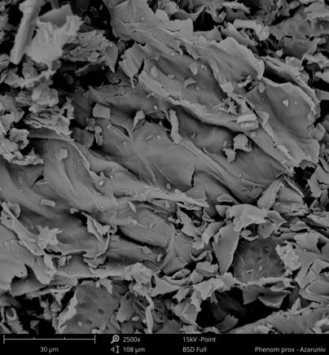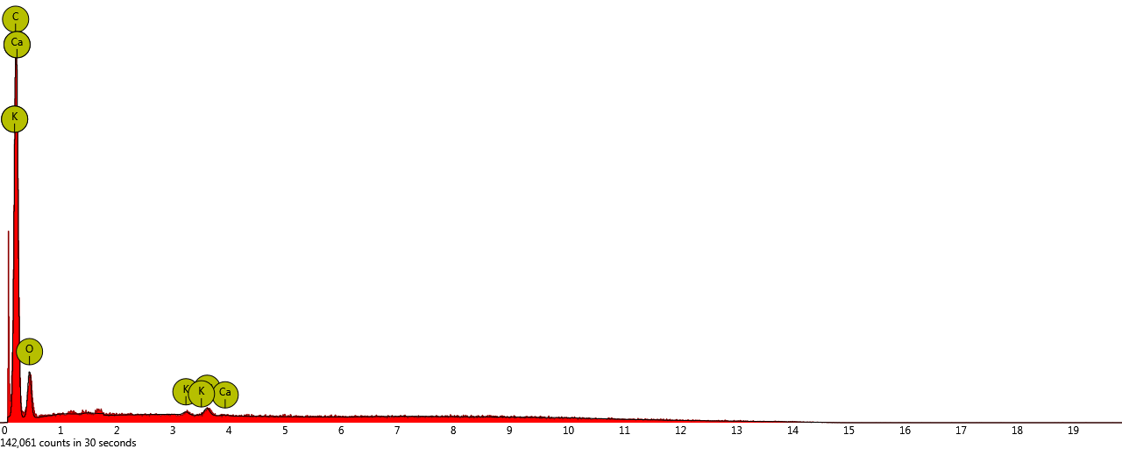
Fig. 2- SEM - EDX analysis of biochar sample prepared from peanut hulls
5. Units
Standard units SI system is the only acceptable system for the scheme of the issues. Note that the units for the amounts listed in tables and axes titles in shapes should not be forgotten.
6. Footnotes
If using footnotes is inevitable, use the font Times New Roman 10pt.
7. Conclusion section
Each Paper should be provided with a summary of the research results presented in the article at the end of the context as the conclusion section. Possible recommendations are also presented in this section.
8. Acknowledgement (optional)
If necessary, a brief appreciation can be mentioned before the list of references.
References
The reference list section is the last part of the article, which is not assigned a title number. References and sources are given in alphabetical order in this section. Mentioning of each reference in the text is based on author-year system. The font size used for Persian references (B Nazanin 11pt) and for English references will be the same as other parts of the article with a smaller size (Times New Roman 10pt). After typing each reference, a space of 6 pt with the next reference is required. The specifications of each reference must be presented in a complete and standard manner according to the APA sixth edition style (available in the References menu in Word version 2013).
For example:
DOE, (2022, June 10). Permissible limits of soil pollution and pollutants entering it (According to the soil protection law). Organizational standards. Retrieved July 30, 2020, from https://wsm.doe.ir/portal/home/?673823
Friedlova, M. (2010). The influence of heavy metals on soil biological and chemical properties. Soil and Water Research, 5(1), 21-27. doi:10.17221/11/2009-SWR
Ghosh, P., & Das, S. P. (2022). Unraveling a dynamic ameliorant of heavy metal-polluted soil: Biochar. In R. T. Kapoor, & M. P. Shah, Biochar: Applications for bioremediation of contaminated systems (pp. 163-184). Berlin: Walter de Gruyter GmbH & Co KG.
Gonzaga, M., de Jesus Santos, J., Ganassali Junior, L., Fontes, P., A. J., & Gonzaga, T. (2022). Copper uptake, physiological response, and phytoremediation potential of Brassica juncea under biochar application. International Journal of Phytoremediation, 24(5), 474-482. doi:10.1080/15226514.2021.1954875

